**How to Make a What-If Analysis Using Parameters?**

Parameters are one of the most powerful tools available in Tableau for exploring your data and providing interactivity to your end users. The best way to think of parameters is that they act as wildcards. In the simple algebraic equation 2X = 16, the value of X would be the parameter; in this case, equal to 8. The reason parameters are so powerful is that you or your end users can change the value of X from 8 to any number, which will change the results of a view.

The concept will be used to create a What-If analysis that will show us what would happen if we improved our sales from 0 – 100%. Parameters come in many different forms, but for this analysis, we will be creating a parameter from integers, or whole numbers. For this exercise, the Superstore dataset will be used.

Let’s start by creating a simple line graph showing sales over time:

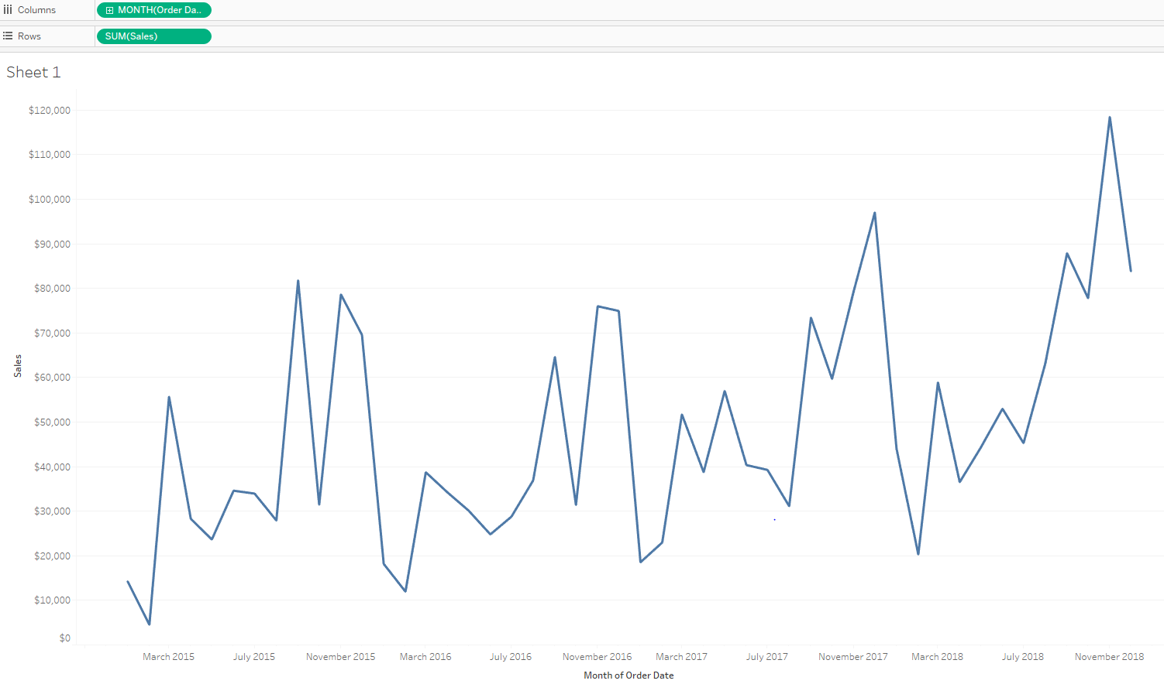

Create a Whatif Parameter

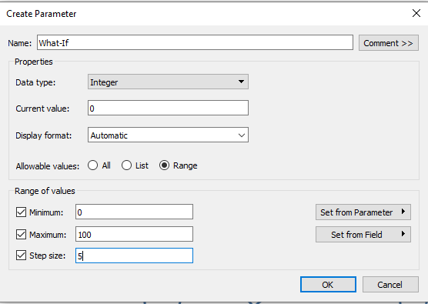

For the purpose of this what-if analysis, we will set the current value to zero, which will end up not changing our view at all the first time we use the parameter. We will also choose range and set the range from zero to 100 with a step size of five. This means that the end user can select any number between zero and 100 in increments of five.

This parameter is a dependent variable, meaning that it does not do anything on its own. To use it in our view, we will create a calculated field that leverages this parameter to calculate the value dynamically. We are interested in creating a what-if analysis that shows how our sales would change if they improved by 0 – 100 percent.

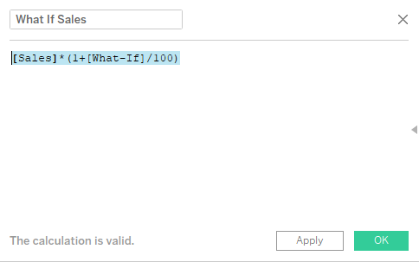

Now that we have our parameter in a calculated field, we can use it in a view. To create two lines on the same axis, one for actual sales and one for what-if sales, drag the measure values from the Measures to the rows shelf after removing the sum(sales). Show the parameter control for what-If parameter.

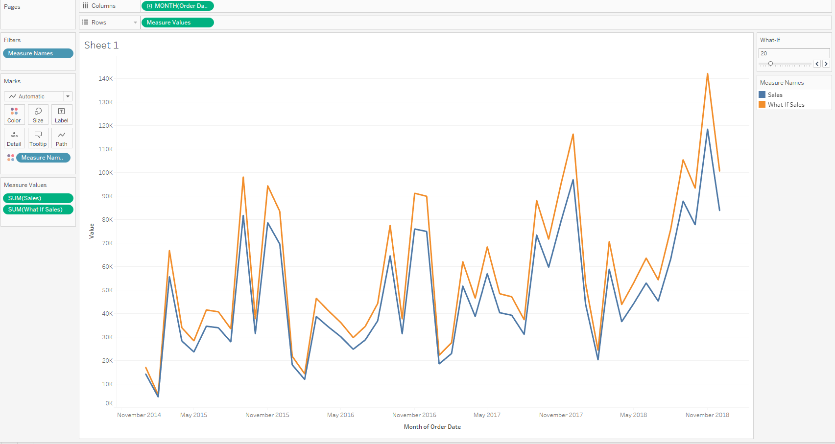

Change the quick table calculation for both Sum(sales) and Sum(What If Sales) to running total for a different view.

